

**Pricing for Perfection**

Speech given by

Sir John Gieve, Deputy Governor, Bank of England

At the Bank of England 14 December 2006

1

All speeches are available online at [www.bankofengland.co.uk/publications/Pages/speeches/default.aspx](http://www.bankofengland.co.uk/publications/Pages/speeches/default.aspx)

# Introduction

Many of you will have seen the new *Financial Stability Report (FSR)* that we published in July. Our aim in that *Report* was to set out more concisely and clearly than in previous years what we considered the main risks to the stability of the UK’s financial system.

The bottom line was that the financial system looked pretty resilient to disturbances in the near-term, but there were some underlying, longer term, vulnerabilities lurking in the background. Some related to potential mismatches or mis-pricing in international financial markets. Others to extended balance sheet positions at home and abroad. And some reflected structural dependencies across the financial system, for example, on the smooth functioning of financial infrastructure. Our view was that they were unlikely to cause problems in the near future but there was a non-negligible risk that they could crystallise rapidly and disruptively for the financial system.

On past form we would be publishing the next *Report* this month but we have decided to change the publication schedule. Future *FSRs* will appear in the Spring and Autumn rather than Summer and Winter. So the 2007 editions are planned for late April and late October.

But in case four months is too long to wait, I want to use my comments today to set out our assessment of prospects for financial stability as we near the end of 2006.

# Recent developments

Our view remains that near-term risks to UK financial stability are low.

That is mainly a reflection of the continuation of broadly benign macroeconomic conditions in the UK and globally A rebalancing in global sources of growth does appear to be under way - and we are watching developments in the US economy and movements in the US dollar closely – but overall the global economy remains strong.

UK financial institutions profitability and capital levels have remained robust, providing them with a buffer against future disturbances.

Financial markets have also demonstrated resilience over the past six months. Markets were turbulent at the time we were preparing the July *FSR*. It was unclear whether we were at the start of a significant correction. The subsequent rebound in asset prices, and declines in measures of volatility, showed that it was a pause not a sustained change in risk appetite.

More recently, we have seen huge losses at the Amaranth hedge fund. These losses exceeded those of LTCM, yet markets facilitated a smooth wind down in positions. That is reassuring though some questions remain about the capacity of markets to handle such a disturbance if the macroeconomic backdrop and the balance sheets of major institutions were less rosy. The incident may also raise some questions about how effectively market forces are acting to restrain those taking outsized risk positions, something that I will return to in a moment.

Taken together, these developments provide a strong baseline for financial stability. But the risks that we pointed to in July are still there. In particular, we pointed to the risk that financial firms concerned about losing market share in rapidly expanding markets might pay less attention than they should to their resilience to unexpected shocks.

[Chart 1] gives our assessment of developments since July. It shows that a number of the vulnerabilities have edged up a little as leveraged buy-out (LBO) activity and commercial property lending have grown and as the number of personal insolvencies has increased.

On the other hand, the slowdown in the US economy and the beginning of a narrowing in its trade balance may have reduced the risks on that side, although we didn’t judge this material enough to change our overall assessment.

We know how easy and how fruitless it can be to draw up long lists of things that could go wrong without paying attention to their likelihood. So we try to take a balanced view that recognises not just what could go wrong but also recognises changes that we think have a positive impact on financial stability. For example, I have been clear that, in the long run, the growth of derivative markets and the development of new players like hedge funds should help to price risks better and spread them more widely, and thus make the financial system more resilient.

However, there is no denying that financial markets are liable to overshoot. And it is particularly important to stay alive to this risk when new records are being set for leveraged bids, returns on equity and City bonuses. Over-optimism in the financial system can have costs not just for the consenting counterparties but more broadly across the economy. By talking to you individually, drawing the threads together with our own analysis and feeding back a dispassionate but informed assessment of what your actions and plans add up to, we hope we can inform your decisions and thus help to head off instability.

# Low volatility

One of the main vulnerabilities on our league table is low risk premia in financial markets

* that is, the low level of compensation that investors are demanding to hold risk. In my remaining remarks I want to offer some observations on a closely related and interconnected topic: the low level of volatility in a number of asset classes.

My colleague Paul Tucker has recently commented on low historic volatility. [Charts 2 to 4] show how the volatility of asset returns has come down for equities, bonds, and exchange rates to low levels by modern standards. One needs to go back to the Bretton Woods era to get volatility levels as low as at present.

Of course the reduction in the volatility of returns – and the lower compensation for future volatility embedded in risk premia – is responding to some real changes in the world. You might break down sources of uncertainty about future returns into three components: macroeconomic risks, financial risks and risks in the broader environment.

Macroeconomic volatility has fallen considerably over the last decade in many economies [Chart 5]. In the real economy, greater flexibility in labour and product markets, especially openness to foreign competition through trade and immigration, has enabled smoother adjustment to shocks. On the price side, central bank independence and inflation targeting have contributed to greater price stability.

There is also greater depth and sophistication and fewer rigidities in financial markets. Innovation has created a variety of products enabling more and better risk transfer by financial market players and greater choice for end-investors. Greater financial market flexibility can support macroeconomic stability by keeping credit and liquidity available during periods of stress.

But risks in the broader environment haven’t gone away. Threats from ecological or biological disasters, fraud, political conflict and terrorism seem as high as ever. And these are risks we have identified. As ever there may be some significant “unknown unknowns”.

So while there are some good reasons for the reduction in financial risk premia significant risks do remain. The question is how well are they priced? Are there any reasons for thinking that markets may be underpricing risk? I think there may be.

# Low risk premia and low volatility

Sustained low economic and financial market volatility is bound to have implications for the level of compensation for risk that investors require in asset prices.

In theory if assets become fundamentally less risky, then investors should receive a capital gain but should accept a lower future rate of return. If there have been signs of the capital gains, it is less clear that investors have revised down their expectations of rates of

return on their portfolios. Indeed the pressure is to go beyond performing relatively well against your peers and to produce absolute returns. This has been fuelling a fierce search for yield and for ‘excess returns’ by asset managers who have to respond to this demand. Delivering on such a commitment in a world of low volatility takes impressive stock picking skills; buying or selling mis-priced assets and spotting emerging trends before the rest of the market.

Clearly not everyone can beat the market. Some asset managers will be able to do so for a while either through luck or good judgement and their challenge is to keep ahead – often with the extra funds that their performance has attracted. Their competitors face added pressure to catch up. Both are bound to be tempted to take on greater risk to generate absolute returns.

Of course this syndrome is widely recognised. Investment mandates and management remuneration are often measured against a risk-adjusted benchmark to avoid rewarding such activity. But it can take considerable efforts to spot such behaviour. The proliferation of new and highly complex financial instruments is making it harder to assess the incidence of underlying risk. The assumptions underlying the valuation of positions in such instruments are often unclear.

Many of these products have the effect of selling insurance against unlikely financial market events. In so far as there has been a genuine increase in the stability of the economy and financial markets, selling volatility is less risky than it used to be. But it can be more risky than it appears.

Our market contacts often cite the example of selling ‘out-of-the-money’ options as a popular strategy recently. Here the seller receives a steady stream of small payments today in return for paying up in the unlikely event that the price of an underlying instrument moves significantly from its current value. With sufficient leverage, a small payment stream can be turned into a tidy return. But as all insurers know, the key to long term return is to spread your risks widely or to avoid correlated risks.

In assessing risk in financial markets, a common metric is correlation of positions with the market return. But this is quite inappropriate in this case. The value of a ‘deeply-out-

of-the-money’ option has relatively low correlation with movements in the price of the underlying instrument or the market generally. So a simple measure of riskiness based on historical correlations will mistakenly show a leveraged out-of-the-money option trade as providing a good risk/return trade-off. In the jargon, selling volatility protection can be one way to generate ‘beta disguised as alpha’.

One would usually expect that any mispricing of risk here would be counteracted by market forces. Countervailing strategies – buying volatility - should be profitable in the long run. The problem is that it requires patience, persistence and deep pockets. Going ‘long’ volatility means being prepared to make regular small payments and hoping to be compensated by a large irregular payoff. In a world of short run return targets, it is not surprising to find this is unpopular.

If mispricing of this sort is underway it would show up in higher asset prices and lower implied volatilities across a range of markets. And implied volatilities are at or around historic lows in equity markets, bond markets, credit markets and foreign exchange markets [Chart 6-8] despite the market turbulence during May and June and recent rumblings on the dollar.

# Implications of low risk premia

These low levels of implied volatility – and associated low level of risk premia – can have real implications for the economy and the stability of the financial system.

In the corporate sector, for example, low risk premia may be one factor that has supported the rapid growth in private equity backed LBOs [Chart 9]**.** Spreads on high yield corporate debt have narrowed sharply in recent years, to the point where there seems very little compensation for credit risk, and almost none for liquidity risk [Chart 10]. A combination of squeezed corporate credit spreads and low reference risk-free government yields has resulted in the lowest nominal cost of borrowing for corporates since the 1950s.

In the July *FSR* we included a rough estimate that - other things equal - LBOs in 2004 and 2005 would raise the future probability of corporate default by 20 basis points. Given recent activity we now estimate it will add around 40 basis points over coming years

relative to the current average probability of corporate default of about 2.0%. Given the funds already raised by private equity firms, this might be expected to increase further in 2007.

Furthermore, there is anecdotal evidence that other corporates have increased leverage in defence – taking the view that it is imprudent to be ‘under-geared’ in an environment where private equity firms are flush with cash. Indeed, the CFO of one FTSE 250 company which geared up significantly to avoid being taken over remarked that “we have seen almost no drawbacks from being junk”.

Another example of low implied volatilities and risk premia affecting risk taking occurs in cross border capital flows. In this case, low implied volatilities on interest rates and exchange rates can support cross-border carry trades because the yield pick up looks attractive when you can hedge the worst risks quite cheaply [Chart 11]. The continued smooth financing of global imbalances through these carry-trades in turn leads to low volatility. But this can of course work in reverse. Foreign exchange volatility has jumped up since the US Thanksgiving Day holiday. If this volatility were to persist the perceived risks in the carry trade would increase.

The common characteristic of these examples is that low implied volatilities reduce the apparent riskiness of portfolios and can encourage investors to take on more risk. And if implied volatilities are not a good measure of future volatility, they will end up bearing more risk than they expected.

Avoiding this pitfall requires diligent risk assessment by investors and other counterparties. That is what is needed for market discipline to do its work. It requires both adequate disclosure of risk-relevant information and its effective use in investment decisions. In the case of the hedge fund sector, for example, it seems likely that greater institutional investor interest will continue to raise the bar on disclosure requirements, particularly for those generating returns using complex products where traditional measures like value-at-risk (VaR) may fail to capture fully the underlying risks.

# Conclusions

To conclude, our overall assessment remains benign. The financial sector is strongly capitalised and well placed to handle even large shocks like Amaranth. The rapid pace of innovation in financial markets also promises better and wider distribution of risk which is good not just for the financial sector’s stability but should support more risk taking in the real economy. Greater investment could deliver stronger medium and long term growth.

But there remain a number of sources of vulnerability in the world economy and in financial markets which firms need to bear in mind.

Volatility is low, and as time passes longer memories are needed to remember when it was high. While there have certainly been improvements in macro performance in recent years, I do not know a central banker who is not surprised at the faith that markets appear to have in us to keep the great stability going. And the risks in the wider environment are as great as ever.

It is not clear to me that these risks are fully priced into the market. Market forces may not have been able to correct any excess optimism given the incentives and constraints of participants operating in a world with a good deal of opaqueness about risk taking.

In closing, I would stress that I am not saying market participants should avoid risk. But I do think it is important that market participants recognise that risk has not gone away, and that there are limits in the ability of financial engineering to insulate the financial system in aggregate against risk. Given the rapid pace of innovation in financial markets and products and the low level of risk premia, investors may need to take particular care to understand the risks they are exposed to. More than in the past, they may need to ask some searching questions about how funds are being invested and how risks are being managed. One approach might be to put greater emphasis on stress test results as well as more conventional risk metrics. Failure to ask probing questions could prove costly for those directly involved – and, of greater concern, to others in the system – as and when the credit cycle turns.

# Chart 1

**Net assessment of news since the July 2006 *FSR***

A significant increase in risk

A slight increase in risk

**Vulnerability** Low risk premia Global imbalances

Global corporate debt UK household debt LCFI stress Infrastructure disruption

Source: Bank calculations.

Broadly unchanged

A slight decrease in risk

A significant decrease in risk

**Probability(a) Impact(b)**

|  |  |
| --- | --- |
|  |  |
|  |  |
|  |  |
|  |  |
|  |  |
|  |  |

* 1. Assessed change in the probability of a vulnerability being triggered over the next three years.
  2. Assessed change in the expected impact on major UK banks' balance sheets if a vulnerability is triggered.

# Chart 2

**Volatility of equity markets(a)(b)**

Percentage points

30

25

20

15

10

5

0

80 82 84 86 88 90 92 94 96 98 00 02 04 06

1. Smoothed by Hodrick Prescott filter.
2. Average of S&P 500 and FTSE 100.

# Chart 3

**Volatility of foreign exchange markets(a)(b)**

Percentage points

14

12

10

8

6

4

2

0

80 82 84 86 88 90 92 94 96 98 00 02 04 06

1. Smoothed by Hodrick Prescott filter.
2. Average of USD/GBP, JPY/USD and EUR/USD.

# Chart 4

**Volatility of government bond markets(a)(b)**

Percentage points

16

14

12

10

8

6

4

2

0

80 82 84 86 88 90 92 94 96 98 00 02 04 06

1. Smoothed by Hodrick Prescott filter.
2. Average of US, UK and Japanese 10-year bonds.

# Chart 5

**Macroeconomic volatility (a)(b)**

Percentage points

5.5

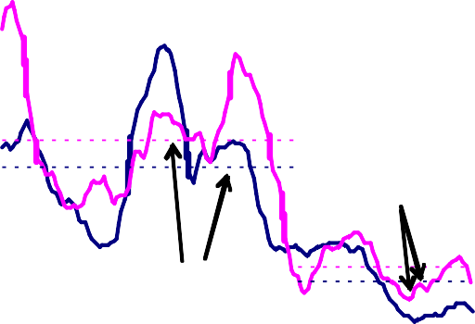

US

UK

Average

(1990-today)

Average

(pre-1990)

5.0

4.5

4.0

3.5

3.0

2.5

2.0

1.5

1.0

0.5

0.0

60 64 70 75 80 85 90 95 00 05

1. Five-year average.
2. Smoothed - 1-year rolling-window realised volatility of annual real GDP growth.

# Chart 6

**Implied equity market volatility (a)**

Per cent

50

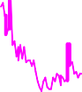

45

40

35

30

25

20

15

10

5

0

86 88 90 92 94 96 98 00 02 04 06

(a) Average of S&P 500, FTSE 100 and Eurostoxx.

# Chart 7

**Implied foreign currency volatility (a)**

Per cent

16

14

12

10

8

6

4

2

0

97 98 99 00 01 02 03 04 05 06

(a) Average of USD/GBP, JPY/USD and EUR/USD.

# Chart 8

**Implied interest rate volatility (a)**

Basis points

250

200

150

100

50

0

85 87 89 91 93 95 97 99 01 03 05

(a) Average of euribor, eurodollar and short sterling.

# Chart 9

**LBO debt issuance (a)(b)**

US$ billions

450

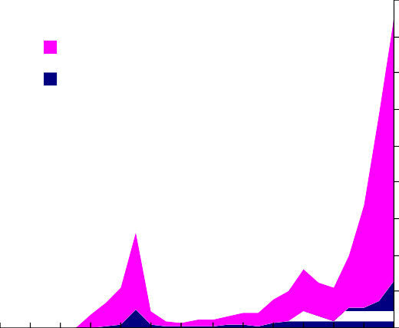

World

UK

400

350

300

250

200

150

100

50

0

80 82 84 86 88 90 92 94 96 98 00 02 04 06

1. LBO issuance is defined here as a subset of

syndicated leveraged issuance, where syndicated leveraged issuance is defined as syndicated sub- investment grade or unrated debt with a spread over LIBOR in excess of 150bp.

1. 2006 data up to 20th November.

# Chart 10

**Credit spreads (a)**

Residual (illiquidity)

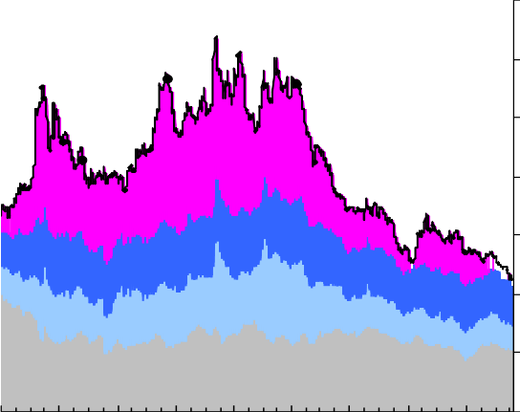Uncertainty about default loss Expected default loss

Risk-free

Per cent

16

14

12

10

8

6

4

98 99

00 01

02 03 04

2

05 06

(a) 20-year cost of borrowing for UK high-yield corporates

# Chart 11

**Yen-funded dollar carry trade ‘attractiveness index’**

Year-on-year private capital flows to US ($bn, net)

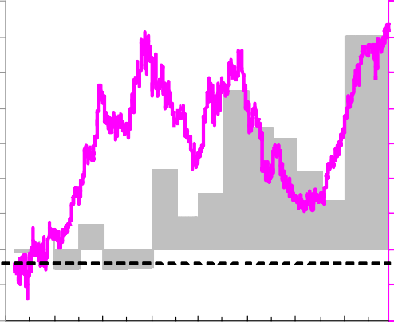700

600

500

400

300

200

100

0

-100

-200

LIBOR yield spread per unit implied volat ilit y

0.7

0.6

0.5

0.4

0.3

0.2

0.1

0.0

-0.1

-0.2

91 93 95 97 99 01 03 05